Here are the mods needed to install Marrad seat bracket into a C5 Z06.

- First you need to use stud extenders because the back of the brackets are too thick and the C5 seat studs are very short. We used Marrad stud extenders and using a cutting wheel cut the nut part off the extenders. This will keep the seat bracket as low as possible. You need to do this for both seats.
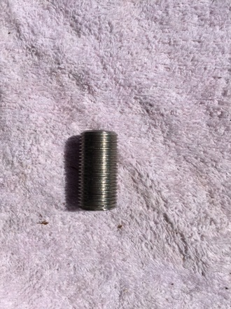
- The next step is to use double nuts locked together to install on the back two factory studs. Don’t forget to use thread locker.
- Next you need to enlarge the back two holes of the brackets to fit the 18m stud extenders. I used a rasping drill bit to do this.
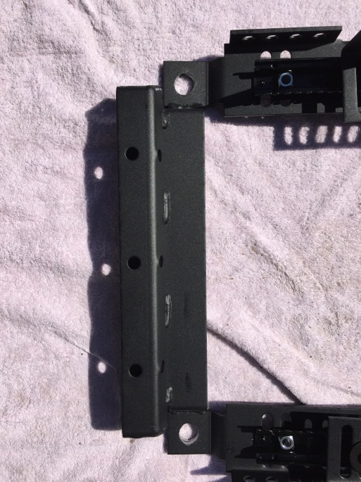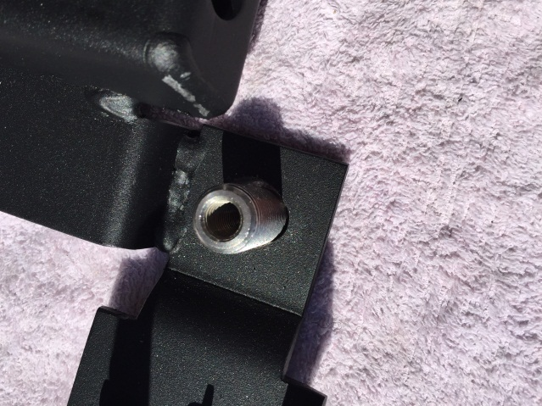

- Next you need to modify the bracket to clear the yaw sensor on the passenger’s side of the car.
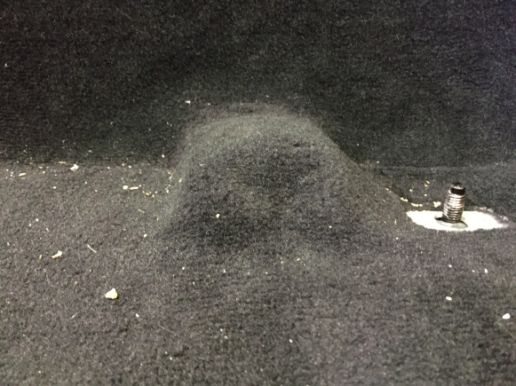

- You are going to need to cut 4.25 inches from the front of the bracket and around .5 inch thick.
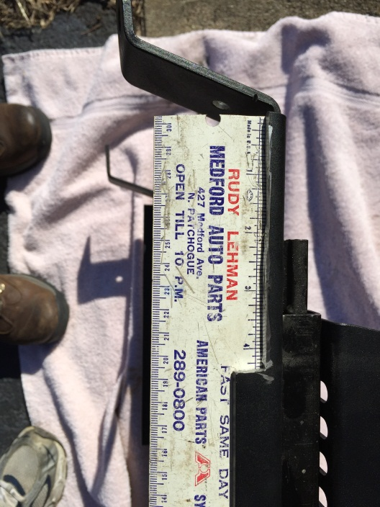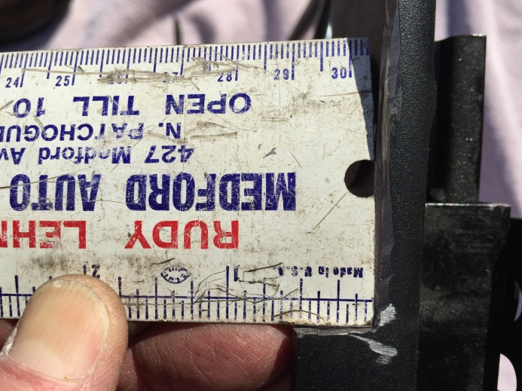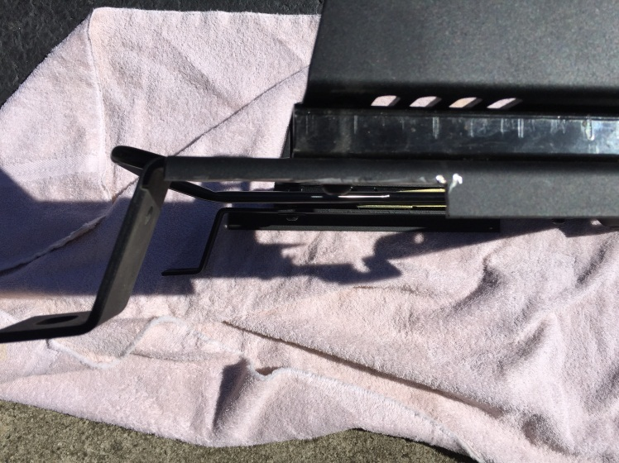

- At this point the brackets will fit on the mounting studs.
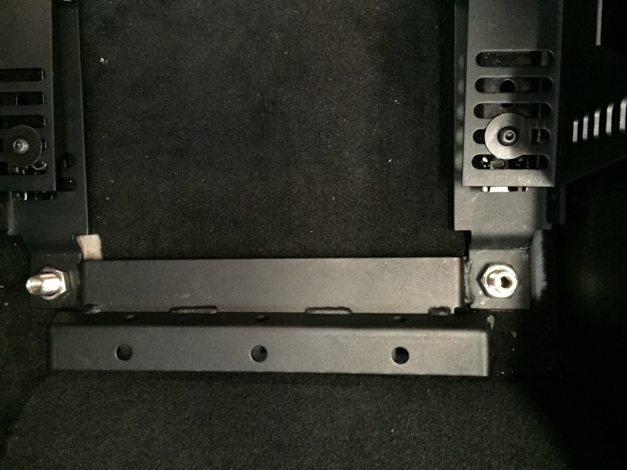

- If you a BK harness bar you need to modify it to work with this bracket. I used a cutting wheel to modify the bottom part of the support bars as seen in the pictures below.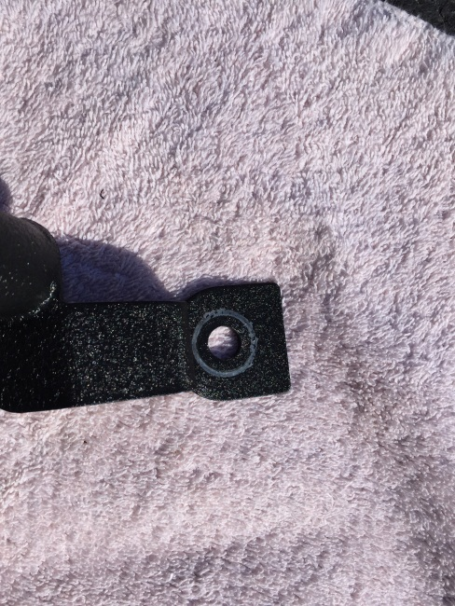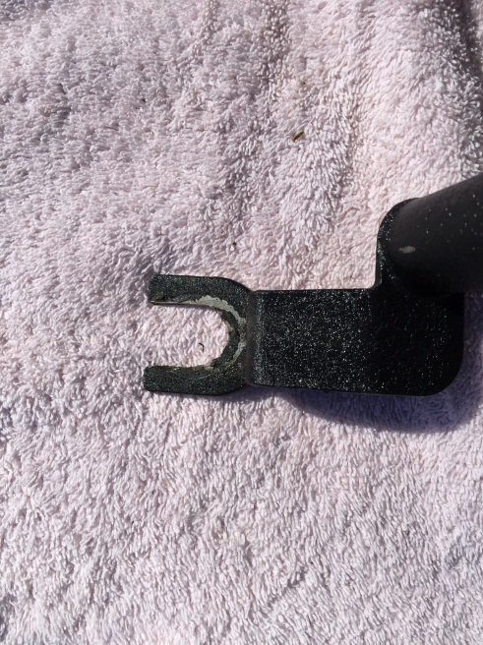

- Here is a picture of the BK and seat bracket installed. It’s a little tricky to get the BK bar installed you need to hold the bracket up a little put the BK bar on top of the bracket and then lower on the stud.

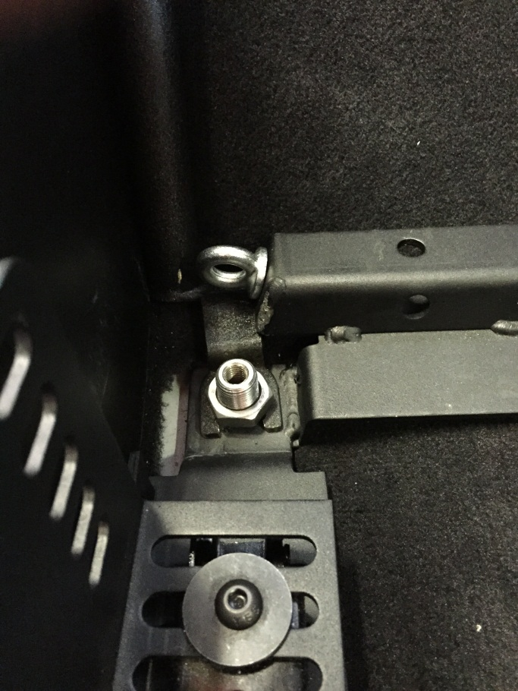

- Depending on the seats used you may have to modify the side mount brackets to fit around the lap belt opening. I am using the 2nd hole in the back lowest my Cobra Imola seat will go and 1st hole upfront. I will have to cut the back of the side mount bracket to fit around the opening.
